Week 1: | Morning Tea | Lunch | Afternoon Tea | Late Snack
Monday | Fresh Fruit  &  Cereal | Provide own lunch | Fresh Fruit  &  Yoghurt | Fresh Fruit
Tuesday | Fresh Fruit  &  Sandwiches | Provide own lunch | Fresh Fruit  &  Sausage Rolls | Fresh Fruit
Wednesday | Fresh Fruit  &  Cereal | Provide own lunch | Fresh Fruit  &  Vege Noodles | Fresh Fruit
Thursday | Fresh Fruit  &  Sandwiches | Provide own lunch | Fresh Fruit  &  Variety Platter A | Fresh Fruit
Friday | Fresh Fruit  &  Cereal | Provide own lunch | Fresh Fruit  &  Mixed Berry Yoghurt Cake | Fresh Fruit
Lil’Antz Menu

Week 2: | Morning Tea | Lunch | Afternoon Tea | Late Snack
Monday | Fresh Fruit  &  Mixed Fruit Muffin | Provide own lunch | Fresh Fruit  &  Cheese Sandwiches | Fresh Fruit
Tuesday | Fresh Fruit  &  Cheese & Crackers | Provide own lunch | Fresh Fruit  &  Variety Platter B | Fresh Fruit
Wednesday | Fresh Fruit  &  Mixed Fruit Muffin | Provide own lunch | Fresh Fruit  &  Flavoured Corn Thins | Fresh Fruit
Thursday | Fresh Fruit  &  Cheese & Crackers | Provide own lunch | Fresh Fruit  &  Sweet or Savory Scones | Fresh Fruit
Friday | Fresh Fruit  &  Mixed Fruit Muffin | Provide own lunch | Fresh Fruit  &  Carrot Cake | Fresh Fruit

When writing our menu Children’s likes & dislikes, season and
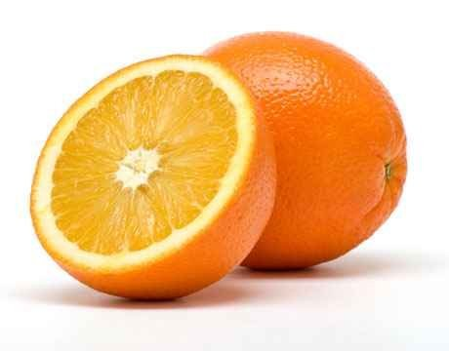
produce availability are taken into consideration.
Lil’Antz discusses the menu with NT Urban Nutritionist to ensure
the Children’s nutritional needs are met.
Lil’Antz Menu

Week 3: | Morning Tea | Lunch | Afternoon Tea | Late Snack
Monday | Fresh Fruit  &  Sandwiches | Provide own lunch | Fresh Fruit  &  Sausage Rolls | Fresh Fruit
Tuesday | Fresh Fruit  &  Cereal | Provide own lunch | Fresh Fruit  &  Variety Platter A | Fresh Fruit
Wednesday | Fresh Fruit  &  Sandwiches | Provide own lunch | Fresh Fruit  &  Quiche | Fresh Fruit
Thursday | Fresh Fruit  &  Cereal | Provide own lunch | Fresh Fruit  &  Yoghurt | Fresh Fruit
Friday | Fresh Fruit  &  Sandwiches | Provide own lunch | Fresh Fruit  &  Banana Bread | Fresh Fruit

Week 4: | Morning Tea | Lunch | Afternoon Tea | Late Snack
Monday | Fresh Fruit  &  Mixed Fruit Muffins | Provide own lunch | Fresh Fruit  &  Cheese Sandwiches | Fresh Fruit
Tuesday | Fresh Fruit  &  Cheese & Crackers | Provide own lunch | Fresh Fruit  &  Custard | Fresh Fruit
Wednesday | Fresh Fruit  &  Mixed Fruit Muffins | Provide own lunch | Fresh Fruit  &  Variety Platter B | Fresh Fruit
Thursday | Fresh Fruit  &  Cheese & Crackers | Provide own lunch | Fresh Fruit  &  Sweet or Savory Scones | Fresh Fruit
Friday | Fresh Fruit  &  Mixed Fruit Muffins | Provide own lunch | Fresh Fruit  &  BBQ Chicken & Pizza Pinwheels | Fresh Fruit
When writing our menu Children’s likes & dislikes, season and
produce availability are taken into consideration.
Lil’Antz discusses the menu with NT Urban Nutritionist to ensure
the Children’s nutritional needs are met.

